|  |
| --- |
| IFMR RURAL FINANCE |
| Application |
|  |
| **IFMR Rural Finance** |
| **10/19/2016** |

|  |
| --- |
|  |

Contents

Process Diagram 3

1. Stage definition 4

2. Stage-role access 4

3. Application Queue 4

3.1 UI specification 4

3.2 Screenshot 4

3.3 Functional requirements 5

3.4 Upload 6

3.5 Download 6

3.6 Reports 6

4. Capturing Application data 7

4.1 UI requirements 7

4.2 Screenshots 40

4.3 Functional requirements 45

4.4 Uploads 46

4.5 Downloads 46

4.6 Reports 46

5. PSYCHOMETRIC TEST 46

5.1 UI specification 46

5.2 Screenshot 46

5.3 Functional requirements 46

5.4 Upload 46

5.5 Download 46

5.6 Reports 46

# Process Diagram



# Stage definition

|  |  |
| --- | --- |
| **Stage** | **Description** |
| Application Queue | The Loan Officer selects a profile from the screening completed list |
| Capture Details | The loan officer captures data and submits the same for risk score calculation |

# Stage-role access

|  |  |
| --- | --- |
| **Stage** | **Applicable Role** |
| Application Queue | Loan Officer |
| Capture Details | Loan Officer |

# Application Queue

## UI specification

|  |  |  |  |  |
| --- | --- | --- | --- | --- |
| **Field name** | **Section** | **Data Type** | **Attribute** | **Population logic** |
| S. No. | Application Queue | Numeric |  |  |
| Applicant Name | Application Queue | Text | Sort/search | From screening stage |
| Business Name | Application Queue | Alphanumeric | Sort/search | From screening stage |
| URN No | Application Queue | Alphanumeric | Sort/search | From screening stage |
| Area | Application Queue | Text | Sort/search | From screening stage |
| City/Village/ Town | Application Queue | Text | Sort/search | From screening stage |
| Pincode | Application Queue | Numeric |  | From screening stage |

## Screenshot

* + 1. Search Page

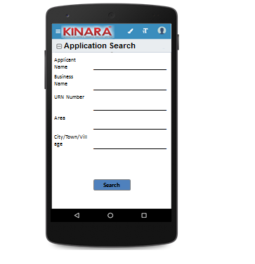

* + 1. Application Queue

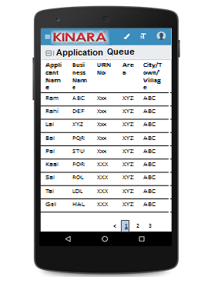

## Functional requirements

**Loan Officer** logs in

* The Loan Officer opens the process dash board, and clicks on Application queue
* If the Loan Officer performs a search without selecting any parameter, then all cases with status ‘Pending for Application’ to be displayed in a tabular format.
* If the Loan Officer searches with ‘Applicant name’, ‘Business name’ or ‘URN no’, then all matching records that are ‘Pending for Application’ (including existing customers) to be displayed in a tabular format.
* The Loan Officer can **search and sort** the profiles based on the following parameters: URN no, Applicant Name, Business Name, Area, City/Village/Town.
* The Loan Officer then selects a profile from the application queue. The queue table should have applicant name, business name, URN No, Area, City/Town/Village as column names.
* All the columns will have **sorting** facility.

## Upload

-NA-

## Download

-NA-

## Reports

-NA-

# Capturing Application data

## UI requirements

|  |  |  |  |  |  |  |  |  |
| --- | --- | --- | --- | --- | --- | --- | --- | --- |
| **Entity** | **Tab** | **Sub tab** | **Section** | **Fields** | **Field Value** | **Mandatory** | **Conditional Mandatory** | **Remarks** |
| APPLICANT | KYC Details |  |  | Aadhar No | Numeric | Yes |  | Aadhar -QR Code Scan (Auto fill Profile & Address data)- from screening |
| Document Capture | Upload | Yes |  | from screening |
| Pan Number | Alpha numeric | Yes |  | from screening |
| Document Capture | Upload | Yes |  | from screening |
| ID Type | Dropdown |  |  | Ration Card, Voter Card, Passport, Pan Card, Aadhar card, Driving License |
| ID No | Alpha numeric |  | Yes | If ID type selected- from screening |
| Valid Up to | Date |  |  | If ID type selected- from screening |
| Document Capture | Upload |  | Yes | If ID type selected- from screening |
| Add Button |  |  |  |  |
| Applicant Details |  |  | Title* | Text | Yes |  | Aadhar QR Code scanning- From screening |
| Name* | Text | Yes |  | Aadhar QR Code scanning- From screening |
| Gender* | Text | Yes |  | Aadhar QR Code scanning- From screening |
| Date Of birth* | Text | Yes |  | Aadhar QR Code scanning- From screening |
| Age | Text |  |  | if age<25 years, then co-app/Guarantor is required- - From screening |
| Father's Name* | Text | Yes |  | Aadhar QR Code scanning- From screening |
| Educational Level* | Dropdown | Yes |  | Below SSLC, SSLC, HSC, Graduate/Diploma/ITI, Professional Degree, Others |
| Religion* | Dropdown | Yes |  | Hindu, Muslim, Christian, Jain, Buddhist, Others |
| Mobile No* | Numeric | Yes |  | From Screening |
| Alternative Mobile No. | Numeric |  |  | From screening |
| Whatsapp Mobile No. | Numeric |  |  | Radio buttons – same as mobile no./same as alternate no./other – free text |
| Email ID | Alphanumeric, special characters |  |  | From screening |
| Preferred language of communication* | Dropdown | Yes |  | Hindi, English, Kannada, Malayalam, Gujarati, Marathi, Tamil, Bengali, Odia, Punjabi, Marwari |
| Mother's Name | Text |  |  | From screening |
| Marital Status | Dropdown | Yes |  | Divorced/Separated, Single, Married, Widow if single, then co-app/Guarantor is required- From screening |
| Spouse Name | Text |  |  | From screening |
| Relationship with Business | Dropdown | Yes |  | Proprietor, Partner, Director, Others - From screening |
| Business Involvement* | Dropdown | Yes |  | Full Time, Part Time, None if biz involvement is not fulltime, then co-app required- From screening |
| Have you ever been a proprietor or partner of any other company | Radio Buttons |  |  | Yes/NO From screening |
| If yes, did the business close? | Radio Buttons |  |  | Yes/NO From screening |
| Month/Year (of business closure) | Date |  |  | MM/YYYY Format  From screening |
| Address Details |  |  | Type Of Address | Dropdown | Yes |  | Permanent, Communication, As per Aadhar card-From screening |
| Care of | Text |  |  | From screening |
| Building* | Alphanumeric, special characters | Yes |  | From screening |
| Street | Alphanumeric, special characters |  |  | From screening |
| Landmark | Alphanumeric, special characters |  |  | From screening |
| Locality | Alphanumeric, special characters |  |  | From screening |
| Pincode* | Text | Yes |  | Pincode search |
| Village/Town/City* | Text | Yes |  | Auto-fill from Pincode master |
| District* | Text | Yes |  | Auto-fill from Pincode master |
| State* | Numeric | Yes |  | Auto-fill from Pincode master |
| Country* | Text | Yes |  | From screening |
| Location | GPS coordinates | Yes |  |  |
| Is the Communication Address same as the Aadhar Card address? | Radio Buttons | Yes |  | Yes/No From screening |
| Line 1 | Alpha numeric |  | Yes | Populate if communication address is different from Aadhar card--from screening |
| Line 2 | Alpha numeric |  |  | Populate if communication address is different from Aadhar card--from screening |
| Area | Alpha numeric |  |  | Populate if communication address is different from Aadhar card--from screening |
| Land Mark | Alpha numeric |  | Yes | Populate if communication address is different from Aadhar card--from screening |
| Pincode | Numeric |  | Yes | Populate if communication address is different from Aadhar card--from screening |
| State | Text |  | Yes | Auto populated based on Pincode; Populate if communication address is different from Aadhar card-- from screening |
| District | Text |  | Yes | Auto populated based on Pincode; Populate if communication address is different from Aadhar card-- from screening |
| City/Town/Village | Text |  | Yes | Auto populated based on Pincode; Populate if communication address is different from Aadhar card-- from screening |
| Landline Number | Numeric |  |  |  |
| Ownership | Dropdown | Yes |  | Own, Rent, Lease -From screening |
| How many years are you living in present Area? | Dropdown | Yes |  | Less than 1 year, 1 to 3 years, 4 to 6 years, 6 to 10 years, greater than 10 years-From screening |
| How many years are you living in current Address? | Dropdown | Yes |  | Less than 1 year, 1 to 3 years, 4 to 6 years, 6 to 10 years, greater than 10 years-From screening |
| Is the Communication Address same as Permanent Address? | Radio Buttons | Yes |  | Yes/No- If no, populate same fields to capture permanent Address-From screening |
| Family Member Details |  |  | Name | Text |  |  |  |
| Relationship with applicant | Dropdown |  |  | Kinara to provide |
| Profession | Dropdown |  |  | Kinara to provide |
| Salary | numeric |  |  |  |
| Education fee (annual) | numeric |  |  |  |
| Is a Co-applicant? | Radio Buttons |  |  | YES/NO |
| **Button to add additional family members** |  |  |  |  |
| Household Financials |  |  | Other Income Source | Dropdown |  |  | Kinara to provide |
| Amount | Numeric |  |  |  |
| **Add button** |  |  |  |  |
| Expense Type | Dropdown |  |  | Kinara to provide |
| Amount | Numeric |  |  |  |
| **Add button** |  |  |  |  |
| Monthly Education Expenses | Auto Calculated |  |  | Based on education fees captured in family member details |
| Family Exp. Based on Education expense | Auto Calculated |  |  | Multiply the education fees with 20/3 |
| Asset Type | Dropdown |  |  | House, Land, Two wheeler, Four wheeler |
| Vehicle make & model | Alphanumeric |  | Yes | If two or four wheeler selected then display this field |
| Registered Owner | Alpha |  | Yes | Display only If Asset type is selected |
| Value of the asset | Numeric |  | Yes | Display only If Asset type is selected |
| **Add button** |  |  |  |  |
| Liabilities |  |  | Debt Source | Dropdown |  |  | Kinara to provide |
| Creditor's Name | Alphanumeric |  |  |  |
| Loan Amount | Numeric |  |  |  |
| Loan Outstanding | Numeric |  |  |  |
| Loan term | Alphanumeric |  |  |  |
| Monthly Instalment | Numeric |  |  |  |
| No. of instalment Paid | Numeric |  |  |  |
| Purpose | Dropdown |  |  | Machine Refinance, Asset Purchase, Debt Consolidation, Working Capital, Line Of Credit, Business Development |
| **Button to add liabilities** |  |  |  |  |
| Bank Statement Details |  |  | IFSC Code | Alphanumeric | Yes |  | IFSC code search |
| Bank Name | Alphanumeric |  |  | Auto fill from IFSC code search |
| Branch Name | Text |  |  | Auto fill from IFSC code search |
| A/C name | Alphanumeric | Yes |  | from screening |
| A/C type | Text | Yes |  | from screening |
| A/C no | Numeric | Yes |  | from screening |
| Banking since | Date |  |  | MM/YYYY Format  from screening |
| Net banking available | Radio Buttons | Yes |  | Yes/No from screening |
| Sanctioned Amount | Numeric |  | Yes | (If A/C type is OD, CC)- from screening |
| Start Month | Date | Yes |  | from screening |
| Total Deposits* | Numeric | Yes |  | from screening |
| Total Withdrawals* | Numeric | Yes |  | from screening |
| Balance as on 15th* | Numeric | Yes |  | from screening |
| No of cheques bounced* | Numeric | Yes |  | from screening |
| No of EMI cheques bounced* | Numeric | Yes |  | from screening |
| **Button to add account** |  |  |  |  |
| References |  |  | Reference Type | Dropdown | Yes |  | Personal-Neighbour, Personal-Relative/friend |
| Full Name | Alphanumeric |  |  |  |
| Mobile No | Numeric |  |  |  |
| Occupation | Dropdown |  |  | Kinara to provide |
| Self-reported Income | Numeric |  |  |  |
| Add Button |  |  |  |  |
| CO-APPLICANT | KYC Details |  |  | Aadhar No | Numeric | Yes |  | Aadhar -QR Code Scan (Auto fill Profile & Address data)- from screening |
| Document Capture | Upload | Yes |  | from screening |
| Pan Number | Alpha numeric | Yes |  | from screening |
| Document Capture | Upload | Yes |  | from screening |
| ID Type | Dropdown |  |  | Ration Card, Voter Card, Passport, Pan Card, Aadhar card, Driving License |
| ID No | Alpha numeric |  | Yes | If ID type selected- from screening |
| Valid Up to | Date |  |  | If ID type selected- from screening |
| Document Capture | Upload |  | Yes | If ID type selected- from screening |
| Co-Applicant Details |  |  | Title* | Text | Yes |  | Aadhar QR Code scanning- From screening |
| Name* | Text | Yes |  | Aadhar QR Code scanning- From screening |
| Gender* | Text | Yes |  | Aadhar QR Code scanning- From screening |
| Date Of birth* | Date | Yes |  | Aadhar QR Code scanning- From screening |
| Age | Numeric |  |  | Auto Calculate based on Date Of Birth entered if age<25 yrs, then co-app/Guarantor is required- - From screening |
| Father's Name* | Text | Yes |  | Aadhar QR Code scanning- From screening |
| Educational Level* | Dropdown | Yes |  | Below SSLC, SSLC, HSC, Graduate/Diploma/ITI, Professional Degree, Others -- From screening |
| Religion* | Dropdown | Yes |  | Hindu, Muslim, Christian, Jain, Buddhism, Others - - From screening |
| Mobile No* | Numeric | Yes |  | from Screening |
| Alternative Mobile No. | Numeric |  |  | From screening |
| Whatsapp Mobile No. | Numeric |  |  | Radio buttons – same as mobile no./same as alternate no./other – free text |
| Email ID | Alphanumeric, special characters |  |  | From screening |
| Preferred language of communication* | Dropdown | Yes |  | Hindi, English, Kannada, Malayalam, Gujarati, Marathi, Tamil, Bengali, odia, Punjabi, Marwari From screening |
| Mothers Name | Text |  |  | From screening |
| Marital Status | Dropdown | Yes |  | Divorced/Seperated, Single, Married, Widow if single, then co-app/Guarantor is required- From screening |
| Spouse Name | Text |  | Yes | If married selected then display this field too. From screening |
| Relationship with Applicant | Text | Yes |  | Spouse, Sibling, Parent, Child, Friend, Others-From screening |
| Relationship with Business | Dropdown | Yes |  | Proprietor, Partner, Director, Others (not to be populated for guarantor)- From screening |
| Business Involvement* | Dropdown | Yes |  | Full Time, Part Time, None |
| Have you ever been a proprietor or partner of any other company | Radio Buttons |  |  | Yes/No From screening |
| If yes, did the business close? | Radio Buttons |  |  | From screening |
| Month/Year (of business closure) | Date |  |  | MM/YYYY format From screening |
| Address Details |  |  | Type Of Address | Dropdown | Yes |  | Permanent, Communication, As per Aadhar card-From screening |
| Care of | Text |  |  | From screening |
| Building* | Alphanumeric, special characters | Yes |  | From screening |
| Street | Alphanumeric, special characters |  |  | From screening |
| Landmark | Alphanumeric, special characters |  |  | From screening |
| Locality | Alphanumeric, special characters |  |  | From screening |
| Pincode* | Text | Yes |  | Pincode search |
| Village/Town/City* | Text | Yes |  | Auto-fill from Pincode master |
| District* | Text | Yes |  | Auto-fill from Pincode master |
| State* | Numeric | Yes |  | Auto-fill from Pincode master |
| Country* | Text | Yes |  | From screening |
| Location | GPS coordinates |  |  |  |
| Is the Communication Address same as the Aadhar Card address? | Radio Buttons | Yes |  | Yes/No From screening |
| Line 1 | Alpha numeric |  | Yes | Populate if communication address is different from aadhar card--from screening |
| Line 2 | Alpha numeric |  |  | Populate if communication address is different from aadhar card--from screening |
| Area | Alpha numeric |  |  | Populate if communication address is different from aadhar card--from screening |
| Land Mark | Alpha numeric |  | Yes | Populate if communication address is different from aadhar card--from screening |
| Pincode | Numeric |  | yes | Populate if communication address is different from aadhar card--from screening |
| State | Auto populated |  | Yes | Auto populated based on Pincode; Populate if communication address is different from aadhar card--from screening |
| District | Auto populated |  | Yes | Auto populated based on Pincode; Populate if communication address is different from aadhar card--from screening |
| City/Town/Village | Auto populated |  | Yes | Auto populated based on Pincode; Populate if communication address is different from aadhar card--from screening |
| Location (GPS) | GPS coordinates |  |  |  |
| Landline Number | Numeric |  |  |  |
| Ownership | Dropdown | Yes |  | Own, Rent, Lease -From screening |
| How many years are you living in present Area? | Dropdown | Yes |  | Less than 1 year, 1 to 3 years, 4 to 6 years, 6 to 10 years, greater than 10 years-From screening |
| How many years are you living in current Address? | Dropdown | Yes |  | Less than 1 year, 1 to 3 years, 4 to 6 years, 6 to 10 years, greater than 10 years-From screening |
| Is the Communication Address same as Permanent Address? | Radio Buttons | Yes |  | Yes/No- If no, populate same fields to capture permanent Address-From screening |
| Family Member Details |  |  | Name | Text |  |  |  |
| Relationship with co-applicant | Text |  |  |  |
| Profession | Text |  |  |  |
| Salary | Numeric |  |  |  |
| Education fee (annual) | Numeric |  |  |  |
| **Buttons to add additional family members** |  |  |  |  |
| Household Financials |  |  | Other Income Source | Dropdown |  |  |  |
| Amount | Numeric |  |  |  |
| **Add button** |  |  |  |  |
| Expense Type | Dropdown |  |  |  |
| Amount | Numeric |  |  |  |
| **Add button** |  |  |  |  |
| Monthly Education Expenses | Auto Calculated |  |  | Based on family details captured |
| Family Exp. Based on Education expense | Auto Calculated |  |  | Multiply monthly education Expenses with (20/3) |
| Asset Type | Dropdown |  |  | House, Land, Two wheeler, Four wheeler |
| Vehicle make & model | Alphanumeric |  | Yes | If two or four wheeler is selected |
| Registered Owner | Alpha |  | Yes | If asset type is selected |
| Value of the asset | Numeric |  | Yes | If asset type is selected |
| **Add button** |  |  |  |  |
| Bank Statement Details |  |  | IFSC Code | Alphanumeric | Yes |  | IFSC code search |
| Bank Name | Alphanumeric |  |  | Auto fill from IFSC code search |
| Branch Name | Text |  |  | Auto fill from IFSC code search |
| A/C name | Alphanumeric | Yes |  | from screening |
| A/C type | Text | Yes |  | from screening |
| A/C no | Numeric | Yes |  | from screening |
|
| Banking since | Date |  |  | MM/YYYY format from screening |
| Net banking available | Radio Buttons | Yes |  | Yes/No  from screening |
| Sanctioned Amount | Numeric |  | Yes | (If A/C type is OD, CC)- from screening |
| Start Month | Date | Yes |  | from screening |
| Total Deposits* | Numeric | Yes |  | from screening |
| Total Withdrawals* | Numeric | Yes |  | from screening |
| Balance as on 15th* | Numeric | Yes |  | from screening |
| No of cheques bounced* | Numeric | Yes |  | from screening |
| No of EMI cheques bounced* | Numeric | Yes |  | from screening |
| **Button to add account** |  |  |  |  |
| GUARANTOR | KYC Details |  |  | Aadhar No | Numeric | Yes |  | Aadhar -QR Code Scan (Auto fill Profile & Address data)- from screening |
| Document Capture | Upload | Yes |  | from screening |
| Pan Number | Alpha numeric | Yes |  | from screening |
| Document Capture | Auto populate/Upload | Yes |  | from screening |
| ID Type | Dropdown |  |  | refer to screening dropdown sheet- from screening |
| ID No | Alpha numeric |  | Yes | If ID type selected- from screening |
| Valid up to | Date |  |  | If ID type selected- from screening |
| Document Capture | Upload | Yes | Yes | If ID type selected- from screening |
| **Add Button** |  |  |  |  |
| Guarantor Details |  |  | Title* | Text | Yes |  | Aadhar QR Code scanning- From screening |
| Name* | Text | Yes |  | Aadhar QR Code scanning- From screening |
| Gender* | Text | Yes |  | Aadhar QR Code scanning- From screening |
| Date Of birth* | Date | Yes |  | Aadhar QR Code scanning- From screening |
| Age | Numeric |  |  | Auto Calculate based on Date of birth- - From screening |
| Father's Name* | Text | Yes |  | From screening |
| Educational Level* | Dropdown | yes |  | Below SSLC, SSLC, HSC, Graduate/Diploma/ITI, Professional Degree, Others |
| Religion* | Dropdown | Yes |  | Hindu, Muslim, Christian, Jain, Buddhist, Others |
| Mobile No* | Numeric | Yes |  | From Screening |
| Alternative Mobile No. | Numeric |  |  | From screening |
| Whatsapp Mobile No. | Numeric |  |  | Radio buttons – same as mobile no./same as alternate no./other – free text |
| Email ID | Alphanumeric, special characters |  |  | From screening |
| Preferred language of communication* | Dropdown | Yes |  | Hindi, English, Kannada, Malayalam, Gujarati, Marathi, Tamil, Bengali, Odia, Punjabi, Marwari |
| Mother's Name | Text |  |  | From screening |
| Marital Status | Dropdown | Yes |  | Divorced/Separated, Single, Married, Widow- From screening |
| Spouse Name | Text |  | Yes | If marital status is married -From screening |
| Relationship with Applicant | Dropdown | Yes |  | Spouse, Sibling, Parent, Child, Friend, Others |
| Business Involvement* | Dropdown | Yes |  | refer to screening dropdown sheet; if biz involvement is not fulltime, then co-app required- From screening |
| Have you ever been a proprietor or partner of any other company | Radio Buttons |  |  | Yes/No  From screening |
| If yes, did the business close? | Radio Buttons |  |  | Yes/No  From screening |
| Month/Year (of business closure) | Date |  |  | MM/YYYY  From screening |
| Address Details |  |  | Type Of Address | Dropdown | Yes |  | Permanent, Communication, As per Aadhar card-From screening |
| Care of | Text |  |  | From screening |
| Building* | Alphanumeric, special characters | Yes |  | From screening |
| Street | Alphanumeric, special characters |  |  | From screening |
| Landmark | Alphanumeric, special characters |  |  | From screening |
| Locality | Alphanumeric, special characters |  |  | From screening |
| Pincode* | Text | Yes |  | Pincode search |
| Village/Town/City* | Text | Yes |  | Auto-fill from Pincode master |
| District* | Text | Yes |  | Auto-fill from Pincode master |
| State* | Numeric | Yes |  | Auto-fill from Pincode master |
| Country* | Text | Yes |  | From screening |
| Is the Communication Address same as the Aadhar Card address? | Radio Buttons | Yes |  | Yes/No From screening |
| Line 1 | Alpha numeric |  | Yes | Populate if communication address is different from Aadhar card--from screening |
| Line 2 | Alpha numeric |  |  | Populate if communication address is different from Aadhar card--from screening |
| Area | Alpha numeric |  |  | Populate if communication address is different from Aadhar card--from screening |
| Land Mark | Alpha numeric |  | Yes | Populate if communication address is different from Aadhar card--from screening |
| Pincode | Numeric |  | Yes | Populate if communication address is different from Aadhar card--from screening |
| State | Auto populated |  | Yes | Auto populated based on Pincode; Populate if communication address is different from Aadhar card--from screening |
| District | Auto populated |  | Yes | Auto populated based on Pincode; Populate if communication address is different from Aadhar card--from screening |
| City/Town/ Village | Auto populated |  | Yes | Auto populated based on Pincode; Populate if communication address is different from Aadhar card--from screening |
| Location (GPS) | GPS coordinates |  |  |  |
| Landline Number | Numeric |  |  |  |
| Ownership | Dropdown | Yes |  | Own, Rent, Lease -From screening |
| How many years are you living in present Area? | Dropdown | Yes |  | Less than 1 year, 1 to 3 years, 4 to 6 years, 6 to 10 years, greater than 10 years-From screening |
| How many years are you living in current Address? | Dropdown | Yes |  | Less than 1 year, 1 to 3 years, 4 to 6 years, 6 to 10 years, greater than 10 years-From screening |
| Is the Communication Address same as Permanent Address? | Radio Buttons | Yes |  | Yes/No- If no, populate same fields to capture permanent Address-From screening |
| **Add Button to add another guarantor** | | | | | | | | |
| BUSINESS | Business Detail |  |  | Referred by | Dropdown | Yes |  | Cold Call, Existing customer Reference, Referral Partner - from screening |
| Referred Name | Text |  | Yes (Based on the dropdown) | If it is cold call then referred name column should not show-from screening |
| Business Name | Text | Yes |  | Auto populated from lead - but editable |
| Business type | Dropdown | Yes |  | Manufacturing, Trading, Services |
| Business Activity | Radio Buttons | Yes |  | If manufacturing -> Job work, Sales If Trading ->Retail, Wholesale,  If Services->B2B, B2C |
| **Add Business Type** |  |  |  | In case of more than one business type. |
| Business Sector | Text | Yes |  | Auto populated from lead - but editable |
| Business Sub sector | Text | Yes |  | Auto populated from lead - but editable |
| ITR available? | Radio Buttons |  |  | Yes/No from screening |
| Business Operating since | Date |  |  | MM/YYYY  from screening |
| Is the Business Registered? | Radio Buttons | Yes |  | Yes/No-from screening |
| Business Registration Type | Dropdown |  | Yes | Tin, SSL No, VAT No, Business Pan Card No, Service Tax No, DIC, MSME, S&E, PAN (Mandatory if PVT LTD)   (If business registered is yes) -from screening |
| Business Registration Proof No | Alpha numeric |  | Yes | (If business registered is yes) from screening |
| Business Registration Date | Date |  | Yes | (If business registered is yes) from screening |
| Valid up to | Date |  | Yes | (If business registered is yes) from screening |
| Document Capture | Upload |  | Yes | from screening |
| **Add Business Registration Type button** |  |  |  | On click show Business Registration Type, Business registration Proof No, Business Registration Date, Valid up to and Document Capture again |
| Constitution | Dropdown |  |  | Proprietorship, Partnership, Private LTD |
| If partnership, how many total partners | Dropdown |  | Yes | 2; 3; 4; >4 (populate only for partnership)-from screening |
| Has anyone else been a partner of your present business | Radio Buttons |  |  | Yes/No from screening |
| If yes, when was that partnership dissolved? | Date |  | Dissolution Agreement required | from screening |
| Address Details |  |  | Line 1 | Alpha numeric | yes |  | Auto populated from lead - but editable |
| Line 2 | Alpha numeric |  |  | Auto populated from lead - but editable |
| Pin Code (Search Option) | Numeric | yes |  | Auto populated based on Pincode- from screening |
| Land Mark | Text | yes |  | Auto populated based on Pincode- from screening |
| State (Auto populate) | Auto populated | yes |  | Auto populated based on Pincode- from screening |
| District(Auto populate) | Auto populated | yes |  | Auto populated from lead - but editable |
| City/Village | Auto populated | yes |  | Auto populated from lead - but editable |
| Location (GPS) | GPS coordinates | yes |  | from screening |
| Landline Phone | Numeric | yes |  | from screening |
| Ownership (Owned/Rent/Lease) | Dropdown | yes |  | refer to screening dropdown sheet-from screening |
| How many years business in present Area? | Dropdown | yes |  | refer to screening dropdown sheet-from screening |
| How many years business in current address? | Dropdown | yes |  | refer to screening dropdown sheet-from screening |
| Employee Detail |  |  | No of Male Employees | Numeric |  |  |  |
| No of Female Employees | Numeric |  |  |  |
| Average Monthly Salary | Numeric |  |  |  |
| Buyer Detail |  |  | Buyer Name | Alpha numeric |  | Yes | Based on Sector definition buyer registration should be mandatory (Only applicable for manufacturing) |
| Customer Since | Dropdown |  | Yes |  |
| Sector | Dropdown |  | Yes |  |
| Sub Sector | Dropdown |  | Yes |  |
| Product | alpha numeric |  |  |  |
| Payment terms (days) | numeric |  |  |  |
| Payment date | Date |  |  |  |
| Payment Frequency | Dropdown |  |  |  |
| Receivables Outstanding / Customer Credit | numeric |  |  |  |
| **Add Button** |  |  |  |  |
| Business Financials | Income | Through Sales | Buyer Name | Dropdown |  |  | dropdown list Auto populated from buyer details-Add all the buyer's name here as a dropdown list |
| Income type | Radio Buttons |  |  | Cash/Invoice |
| Amount | Numeric |  |  |  |
| Date | Date |  |  | ??? |
| **Add Button** |  |  |  |  |
| Other Business Income | Income Source | Dropdown |  |  | Kinara to provide |
| Amount | Numeric |  |  |  |
| Date | Date |  |  | ??? |
| **Add Button** |  |  |  |  |
| Expenses | Raw material expense | Vendor Name | Alphanumeric |  | Yes | If the Last month "Income details " is manufacturing or Trading the purchase bill is compulsory |
| Type | Radio Buttons |  |  | Cash/Invoice |
| Amount | Numeric |  |  |  |
| Date | Date |  |  |  |
| **Add Button** |  |  |  |  |
| Salary and Wages | Owner's Salary | Numeric |  |  |  |
| Co- Owner's Salary | Numeric |  |  |  |
| Employee's Salary | Numeric |  |  | validation: average of min/max times # of employees, whichever is higher to be used in calculations |
| Fixed Obligations | Payment of Debts | Numeric |  |  | Auto populated from fixed liability section- total monthly Instalment amount |
| Savings/Committee/Chits | Numeric |  |  | Auto populated from Savings section monthly Instalment amount |
| Insurance Premium amount | Numeric |  |  | Auto populated from Insurance section monthly Premium amount |
| Other Expenses | Rent | Numeric |  |  |  |
| Sub-Contractor Payment | Numeric |  |  |  |
| Tools & Consumables | Numeric |  |  |  |
| Electricity Charges | Numeric |  |  |  |
| Transportation Costs | Numeric |  |  |  |
| Repair and Maintenance | Numeric |  |  |  |
| General Admin | Numeric |  |  | Calculated @ 10% of revenue |
| Assets | Current Assets | Cash At Bank | Numeric |  |  | Calculated field-(Avg 6 months balance) |
| Inventory | Raw Material | Numeric |  |  | Applicable for Manufacturing only. For trading, only Finished goods applicable |
| WIP | Numeric |  |  | Applicable for Manufacturing only. For trading, only Finished goods applicable |
| Finished Goods | Numeric |  |  |  |
| Machinery | Machine Description | Alphanumeric |  | Yes | If it is secured Machine details are mandatory |
| Manufacturer Name | Alphanumeric |  |  |  |
| Machine Type | Dropdown |  |  | ??? |
| Machine Model | Alphanumeric |  |  |  |
| Serial Number | Alphanumeric |  |  |  |
| Purchase Price | Numeric |  |  |  |
| Machine Purchased Year | Numeric |  |  |  |
| Present Value | Numeric |  |  | Calculate only 75% of the value |
| Is the Machine New? | Radio Buttons |  |  | Yes/No |
| Funding Source | Dropdown |  |  | ??? |
| Is the Machine Hypothecated? | Radio Buttons |  |  | Yes/No |
| Machine Permanently fixed to building? | Radio Buttons |  |  | Yes/No |
| Machine Bills | Upload |  | Yes | If machine is new then bill needed |
| **Add button** |  |  |  |  |
| Other Fixed assets | Asset Type | Dropdown |  |  | Land, Building, Vehicle, Furniture & Fixtures (Vehicle, Furniture mandatory for trading) |
| Vehicle Make & Model (if asset type is vehicle) | Alphanumeric |  | Yes | If asset type is vehicle |
| Value of Asset | Numeric |  |  |  |
| **Add button** |  |  |  |  |
| Company Liabilities |  | Debt Source | Dropdown |  |  | ??? |
| Creditor's Name | Alphanumeric |  |  |  |
| Loan Amount | Numeric |  |  |  |
| Loan Outstanding | Numeric |  |  |  |
| Loan term | Alphanumeric |  |  |  |
| Monthly Instalment | Numeric |  |  |  |
| No. Of instalment Paid | Numeric |  |  |  |
| Purpose | Dropdown |  |  | Machine Refinance, Asset Purchase, Debt Consolidation, Working Capital, Line Of Credit, Business Development |
| **Add Button** |  |  |  |  |
| Supplier's Name | Alphanumeric |  |  |  |
| Type | Dropdown |  |  | ??? |
| Payment terms (days) | Numeric |  |  |  |
| Amount | Numeric |  |  |  |
| Financial Summary |  | Sales | Numeric |  |  | Auto Calculated field |
| Purchases | Numeric |  |  | Auto Calculated field |
| Operating Expenses | Numeric |  |  | Auto Calculated field |
| Household Expenses | Numeric |  |  | Auto Calculated field |
| Fixed Obligations | Numeric |  |  | Auto Calculated field |
| Net Business Income | Numeric |  |  | Auto Calculated field |
| Bank Statement Details |  |  | IFSC Code | Alphanumeric | Yes |  | IFSC code search |
| Bank Name | Alphanumeric |  |  | Auto fill from IFSC code search |
| Branch Name | Text |  |  | Auto fill from IFSC code search |
| A/C name | Alphanumeric | Yes |  | from screening |
| A/C type | Text | Yes |  | from screening |
| A/C no | Numeric | Yes |  | from screening |
| Banking since | Date |  |  | MM/YYYY Format from screening |
| Net banking available | Radio Buttons | Yes |  | Yes/No  from screening |
| Sanctioned Amount | Numeric |  | Yes | (If A/C type is OD, CC)- from screening |
| Start Month | Date | Yes |  | from screening |
| Total Deposits* | Numeric |  |  | from screening |
| Total Withdrawals* | Numeric |  |  | from screening |
| Balance as on 15th* | Numeric |  |  | from screening |
| No of cheques bounced* | Numeric |  |  | from screening |
| No of EMI cheques bounced* | Numeric |  |  | from screening |
| **Button to add account** |  |  |  |  |
| References |  |  | Reference type | Dropdown | Yes |  | Business Machine Suppliers, Business Material Suppliers, Business Buyer, Business Referral |
| Business Name | Alpha numeric |  |  | Business Buyer- Conditional Mandatory, Others- Optional |
| Full name of POC | Alpha numeric |  |  |  |
| Mobile No | Numeric |  |  |  |
| Business Sector | Dropdown |  |  | Please see Business Sector table |
| Business sub sector | Dropdown |  |  | Please see Business Sub Sector table |
| Self-reported Income | Numeric |  |  |  |
| LOAN DETAILS | Loan Proposal |  |  | Purpose | Dropdown | Yes |  | Machine Refinance, Asset Purchase, Debt Consolidation, Working Capital, Business Development (from screening) |
| Sub-purpose | Dropdown | Yes |  | From screening |
| Do you have assets available for hypothecation | Radio Buttons |  |  | Yes/No from screening (If WC, or BD, or LOC ) |
| If yes, estimated value of assets | Numeric |  | Yes | (auto populated based on fixed assets field) |
| Loan Amount | Numeric | Yes |  | from screening |
| Term | Alpha numeric | Yes |  |  |
| EMI Requested | Numeric | Yes |  | from screening |
| EMI Payment Date Requested | Date |  |  | from screening |
| Frequency | Dropdown | Yes |  | Weekly, monthly, Quarterly, Semi- Annually, Annually |
| Estimated date of Completion | Date |  |  |  |
| Product Type | Dropdown |  |  | auto populated based on Purpose above (refer to screening dropdown sheet- from screening) |
| Customer sign date | Date | Yes |  |  |
| New Asset Details |  |  | Machine | Alphanumeric |  | Yes | Option to add any number of machine |
| Purchase Price | Numeric |  |  | If the loan is taken for Asset purchase then "New Asset" section should be mandatory |
| Expected Income | Numeric |  |  | If the loan is taken for Asset purchase then "New Asset" section should be mandatory |
| Manufacturer Name | Alphanumeric |  |  | If the loan is taken for Asset purchase then "New Asset" section should be mandatory |
| Machine Type | Dropdown |  |  | If the loan is taken for Asset purchase then "New Asset" section should be mandatory |
| Machine Model | Alphanumeric |  |  | If the loan is taken for Asset purchase then "New Asset" section should be mandatory |
| Serial No | Alphanumeric |  |  | If the loan is taken for Asset purchase then "New Asset" section should be mandatory |
| Expected purchase date | Date |  |  | If the loan is taken for Asset purchase then "New Asset" section should be mandatory |
| Machine Permanently fixed to building | Radio Buttons |  |  | Yes / No |
| Hypothecated to Kinara | Dropdown |  |  | option to capture multiple hypothecation details |
| **Add Button** |  |  |  |  |

**Details of Conditional Drop-downs**

1. **Business Type- Manufacturing**

|  |  |  |  |
| --- | --- | --- | --- |
| **Business Type** | **Business Activity** | **Business Sector** | **Business Sub Sector** |
| Manufacturing | Sales | Machine Components |  |
|  | Job Work |  | Agriculture Machinery |
|  | Job work & Sales |  | Satellite Equipment |
|  |  |  | Construction Equipment |
|  |  |  | Textile Machinery |
|  |  |  | Plastics Machinery |
|  |  |  | Chemical Processing Machinery |
|  |  |  | Paper & Paperboard making machinery |
|  |  |  | Food Manufacturing Machinery |
|  |  |  | Semi-conductor Machinery |
|  |  |  | Wire Cutting Machinery |
|  |  |  | Automation Machinery |
|  |  |  | Special Purpose Machinery |
|  |  |  | Aircraft/Defence Machines |
|  |  |  | Air conditioning/Heating |
|  |  |  | Elevator/Conveyor |
|  |  |  | Ovens/Furnaces |
|  |  |  | Office Machinery/Equipment |
|  |  |  | Pumps/Compressors/Valves |
|  |  |  | Power Equipment |
|  |  |  | General Purpose Machinery |
|  |  |  |  |
|  |  | Auto Components | 2-Wheelers |
|  |  |  | 4-Wheelers |
|  |  |  | Light Commercial Vehicles (utility trucks, pickups, etc) |
|  |  |  | Heavy Commercial Vehicles (Trucks/Lorries) |
|  |  |  | Passenger Vehicles (Vans, Buses) |
|  |  |  | Agriculture Vehicles (Tractors, Tillers) |
|  |  |  | Construction Vehicles (Bobcats, Loaders, Compactors, Drillers, Earth-moving, etc.) |
|  |  |  |  |
|  |  |  |  |
|  |  | Fabrication | Welding |
|  |  |  | Tool & Dies |
|  |  | Food Products | Dairy Products |
|  |  |  | Beverage |
|  |  |  | Oils |
|  |  |  | Grain Mills |
|  |  |  | Animal Feed |
|  |  |  | Processing/Preserving meat, fish, vegetables |
|  |  |  | Starch and Starch Products |
|  |  |  | Bakery Goods |
|  |  |  | Prepared Meals & Dishes |
|  |  | Leather | Tanning & Dyeing |
|  |  |  | Footwear |
|  |  |  | Luggage |
|  |  |  | Handbags |
|  |  | Wood | Sawmill |
|  |  |  | Wood Materials |
|  |  |  | Furniture |
|  |  |  | Household goods |
|  |  | Textiles | Spinning |
|  |  |  | Weaving |
|  |  |  | Bleaching |
|  |  |  | Dyeing |
|  |  |  | Dressing |
|  |  |  | Drying |
|  |  |  | Steaming |
|  |  |  | Shrinking |
|  |  |  | Printing |
|  |  | Apparel | Knitwear |
|  |  |  | Ethnic Wear |
|  |  |  | Western Wear |
|  |  |  | Underwear |
|  |  | Paper | Paper Recycling |
|  |  |  | Pulp making |
|  |  |  | Paper & Paper Rolls |
|  |  |  | Paper Products (cups, plates, toys, etc.) |
|  |  |  | Cardboard Paper Products |
|  |  |  | Corrugated Paper Products |
|  |  |  | Carbon Paper & Stationary Items |
|  |  | Printing | Packaging Printing |
|  |  |  | Publication Printing |
|  |  |  | Commercial Printing |
|  |  | Plastics | Plastic Recycling |
|  |  |  | Industrial Injection Moulding |
|  |  |  | Household Injection Moulding |
|  |  |  | Plastic Sheets and Films |
|  |  |  | Plastic Packaging (bags, boxes, cases, et) |
|  |  |  | Optical (eye glass frames, etc.) |
|  |  |  | Housewares |
|  |  |  | Pipes, Tubes and Fittings |
|  |  |  | Other Plastic Moulding & Extrusion |
|  |  |  | Plastic Furniture |
|  |  |  | Medical & Dental Appliances |
|  |  |  | Games & Toys |
|  |  |  | Writing (pens, desk stuff, etc.) |
|  |  |  | Sanitary (tubs, basins, etc.) |
|  |  |  | Travel Goods (luggage, bags, etc.) |
|  |  | Electronics | Electronic Components |
|  |  |  | Computer Components |
|  |  |  | Communication Equipment |
|  |  |  | Measuring & Testing Equipment |
|  |  |  | Optical Instruments |
|  |  |  | Electro-medical Equipment |
|  |  | Electrical | Control Panels |
|  |  |  | Motors |
|  |  |  | Generators |
|  |  |  | Batteries/Accumulators |
|  |  |  | Wiring and Wiring Devices |
|  |  |  | Lighting Equipment |
|  |  |  | Domestic Appliances |
|  |  | Medical Equipment | Medical Instruments |
|  |  |  | Dental Instruments |
|  |  |  | Hospital Equipment |
|  |  | Chemicals | Basic Chemicals |
|  |  |  | Fertilizers & Nitrogen Compounds |
|  |  |  | Plastics & Synthetic Rubber |
|  |  |  | Pesticides & Agro-chemicals |
|  |  |  | Paints, Varnishes, Coatings, Enamels & Lacquer |
|  |  |  | Soap & Detergents |
|  |  | Pharmaceuticals | Antibiotics, Serums, Vitamins |
|  |  |  | Ayurvedic Preparations |
|  |  |  | Homeopathic Preparations |
|  |  |  | Veterinary Preparations |
|  |  |  | Gauze, Bandages, Dressings |
|  |  | Rubber | Rubber Tyres and Tubes |
|  |  |  | Tyre and Tube Repair |
|  |  |  | Elastic Fabrics |
|  |  |  | Footwear |
|  |  |  | Glues & Adhesives |
|  |  |  | Rubber Sports Equipment |
|  |  |  | Boats & Rafts |
|  |  |  | Games & Toys & Balloons |
|  |  |  | Rubber Fittings (plates, sheets, rods, hoses) |

1. **Business Type-Trading**

|  |  |  |  |
| --- | --- | --- | --- |
| **Business Type** | **Business Line** | **Business Sector** | **Business Sub Sector** |
| Trading | Whole Sale | Automobiles | Auto Accessories |
| Retail | Automobiles | Auto Parts |
|  |  | Automobiles | Auto Tyres |
|  |  | Book Stores | Book Stores |
|  |  | Construction | Painting |
|  |  | Construction | Cement |
|  |  | Electricals | Electricals |
|  |  | Electricals | Lighting stores |
|  |  | Electronics | Camera stores |
|  |  | Electronics | Computers/tech shops |
|  |  | Electronics | Home appliances |
|  |  | Electronics | Kitchen appliances |
|  |  | Housewares | Kitchen Goods |
|  |  | Electronics | Mobile shops |
|  |  | Fashion | Baby products |
|  |  | Fashion | Clothing stores |
|  |  | Fashion | Luggage stores |
|  |  | Fashion | Shoe stores |
|  |  | Food & Beverage | Fruit/Veg Stands |
|  |  | Food & Beverage | Provision stores |
|  |  | Food & Beverage | Water Suppliers |
|  |  | Food & Beverage | Snack Shops |
|  |  | Food & Beverage | Sweet Shops |
|  |  | Food & Beverage | Ice-cream shops |
|  |  | Furniture | Wood Furniture |
|  |  | Furniture | Steel Furniture |
|  |  | Furniture | Plastic Furniture |
|  |  | Health & Beauty | Beauty Products |
|  |  | Health & Beauty | Eyewear stores |
|  |  | Health & Beauty | Health food stores |
|  |  | Health & Beauty | Jewellery stores |
|  |  | Health & Beauty | Pharmacy |
|  |  | Health & Beauty | Ayurvedic Medical |
|  |  | Health & Beauty | Homeopathic Medical |
|  |  | Health & Beauty | Sports equipment |
|  |  | Hobbies | Art and crafts store |
|  |  | Hobbies | Musical instruments |
|  |  | Hobbies | Pet goods store |
|  |  | Hobbies | Video stores |
|  |  | Housewares | Home Decor & Gifts |
|  |  | Housewares | Watch and clocks |
|  |  | Industrial | Industrial products |
|  |  | Industrial | Scrap Dealers |
|  |  | Stationary | Stationary |

1. **Business Type-Services**

|  |  |  |  |
| --- | --- | --- | --- |
| **Business Type** | **Business Line** | **Business Sector** | **Business Sub Sector** |
| Services | Retail (Business to Consumer) | Automobiles | Car Maintenance Services |
| Retail (Business to Business) | Automobiles | Tyre Retreading |
|  |  | Education | Education |
|  |  | Health & Beauty | Beauty/Hair |
|  |  | Health & Beauty | Diagnostics |
|  |  | Health & Beauty | Gym/Fitness |
|  |  | Health & Beauty | Salons |
|  |  | Home Care | Appliance Repair |
|  |  | Home Care | Carpentry |
|  |  | Home Care | Cleaning |
|  |  | Home Care | Construction |
|  |  | Home Care | Gardening |
|  |  | Home Care | Movers |
|  |  | Home Care | Painting |
|  |  | Home Care | Pest Control |
|  |  | Home Care | Plumbing |
|  |  | Industrial | Electro-plating |
|  |  | Industrial | Hydro-plating |
|  |  | Industrial | Heat Treatment |
|  |  | Industrial | Industrial Gases |
|  |  | Industrial | Waste & Water Management |
|  |  | Professional | Advertising |
|  |  | Professional | Dry Cleaning/Laundry |
|  |  | Professional | Event Planning |
|  |  | Professional | Financial |
|  |  | Professional | Legal |
|  |  | Professional | Medical |
|  |  | Professional | Opticians |
|  |  | Professional | Real Estate |
|  |  | Software & Tech | Graphic Design |
|  |  | Software & Tech | Software |
|  |  | Software & Tech | Telecommunication |
|  |  | Travel | Hotels |
|  |  | Travel | Restaurants |
|  |  | Travel | Tourism/Travel |
|  |  | Travel | Transport |

## 

## Screenshots

UI layout:

To add Co-Applicant or guarantor, click on + button.

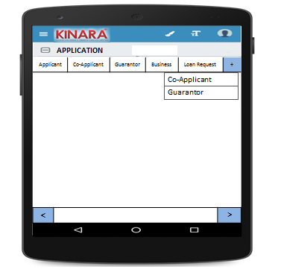

**4.2.1 Applicant**

Entity wise data capture will start with Applicant

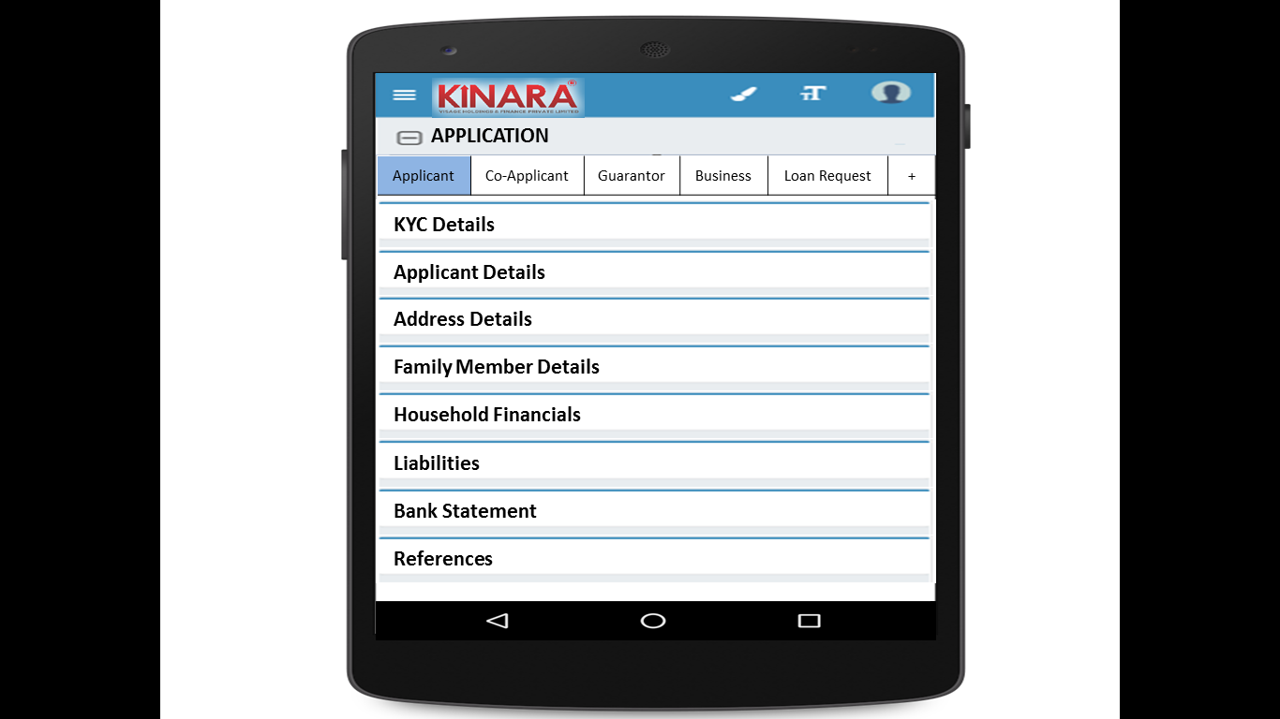

* + - 1. KYC Details:

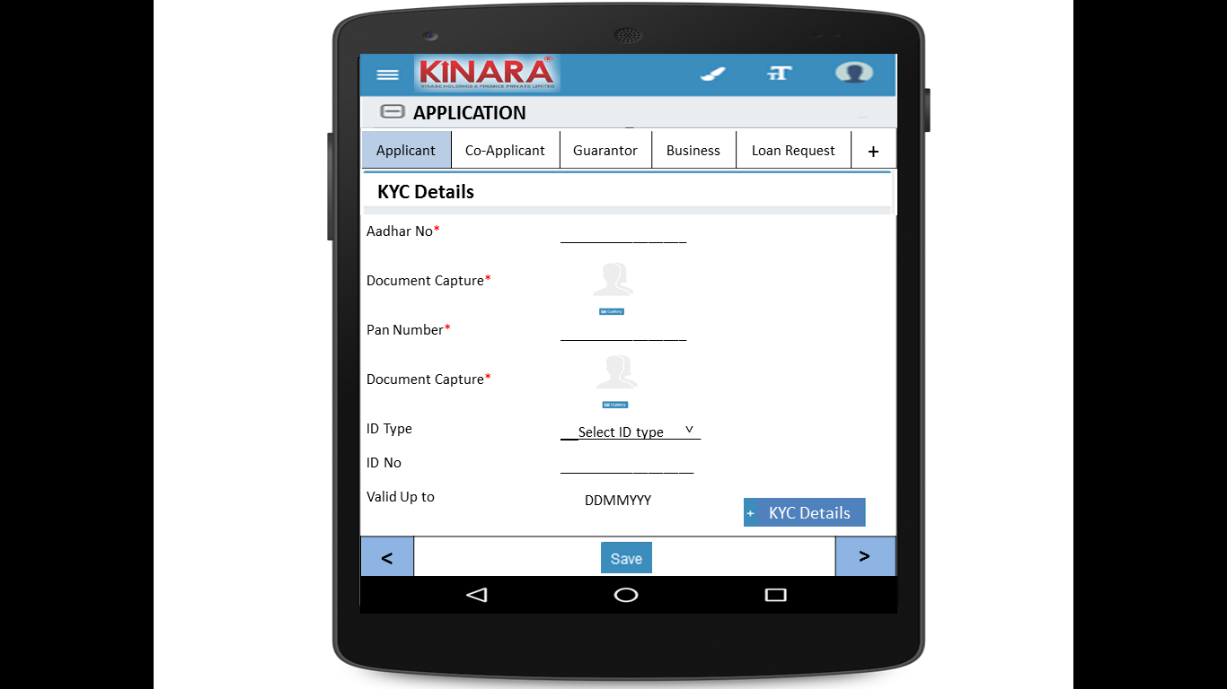

* + - 1. Applicant Details

|  |  |  |
| --- | --- | --- |
| Page 1 | Page 2 | Page 3 |

* + - 1. Address Details

|  |  |
| --- | --- |
| Page 1 | Page 2 |
| Page 3 | Page 4 |

* + - 1. Family Member Details

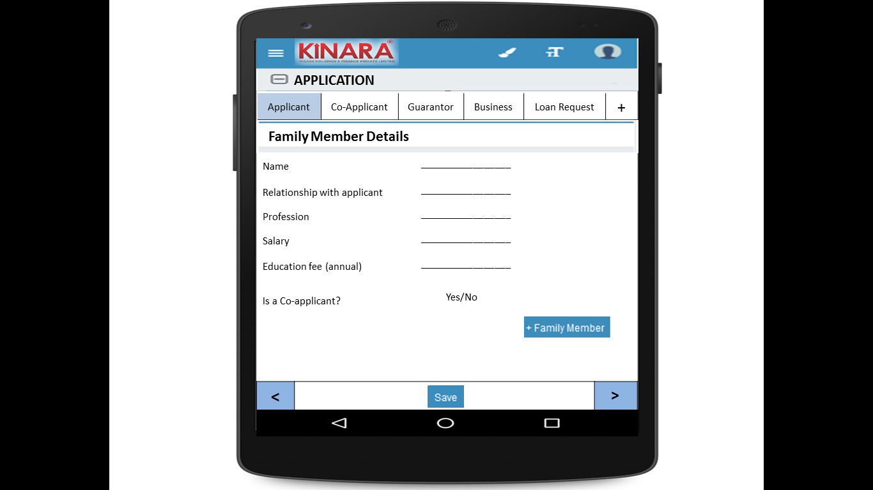

* + - 1. Household Financials

|  |  |
| --- | --- |
| Page 1 | Page 2 |

* + - 1. Liabilities

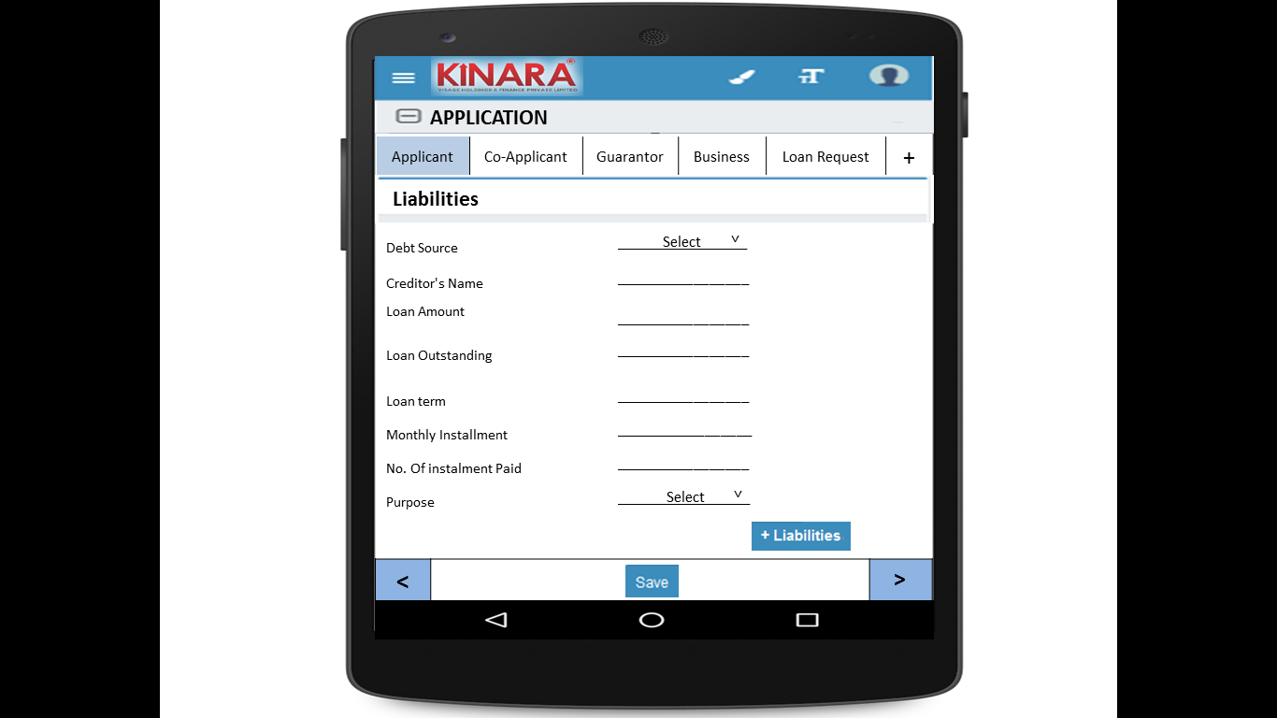

* + - 1. Bank Statement Details

|  |  |
| --- | --- |
| Page 1 | Page 2 |

* + - 1. References

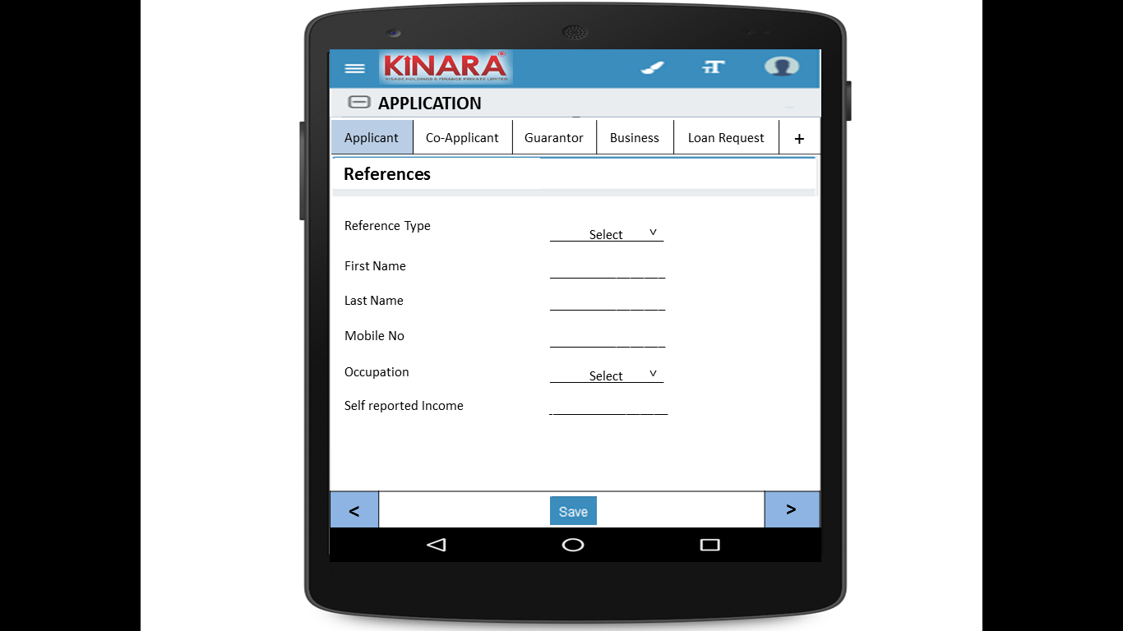

* + 1. **Co-applicant**

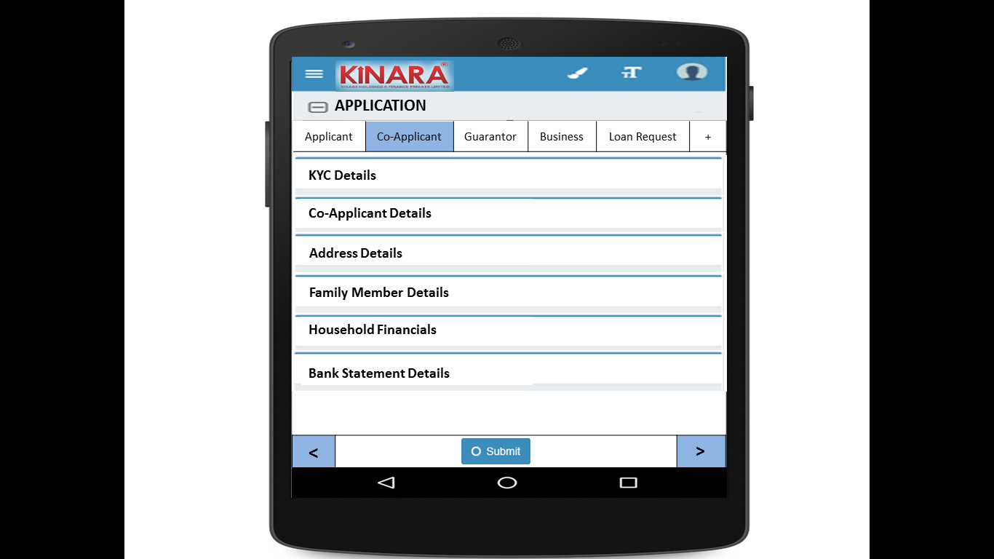

* + - 1. KYC Details

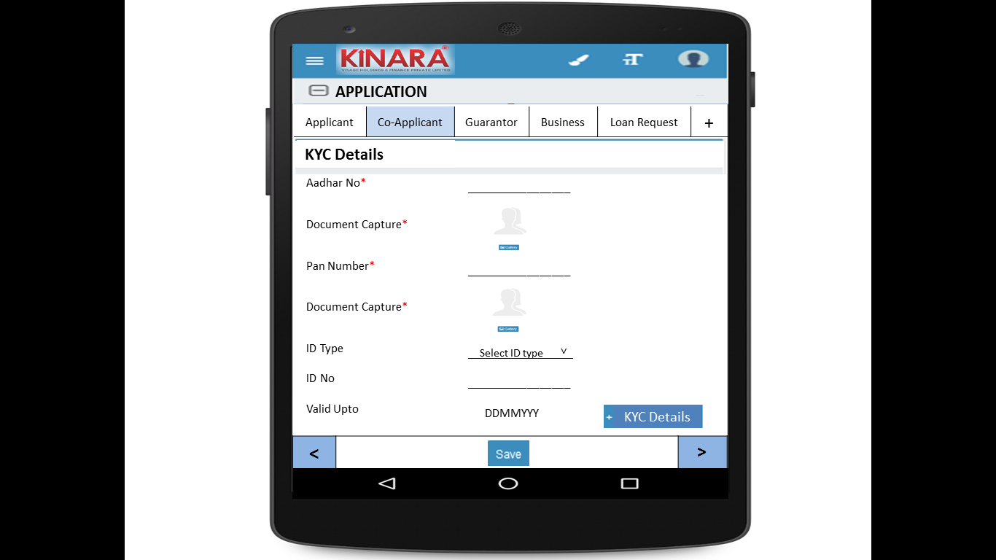

* + - 1. Co-applicant Details

|  |  |  |
| --- | --- | --- |
| Page 1 | Page 2 | Page 3 |

* + - 1. Address Details

|  |  |
| --- | --- |
| Page 1 | Page 2 |
| Page 3 | Page 4 |

* + - 1. Family Member Details

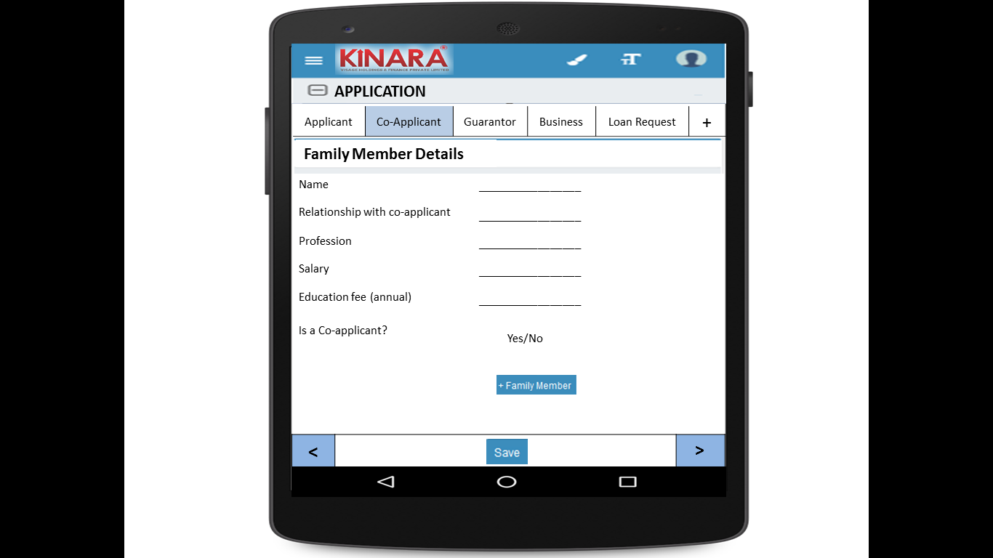

* + - 1. Household Financials

|  |  |
| --- | --- |
| Page 1 | Page 2 |

* + - 1. Bank Statement Details

|  |  |
| --- | --- |
| Page 1 | Page 2 |

* + 1. **Guarantor**

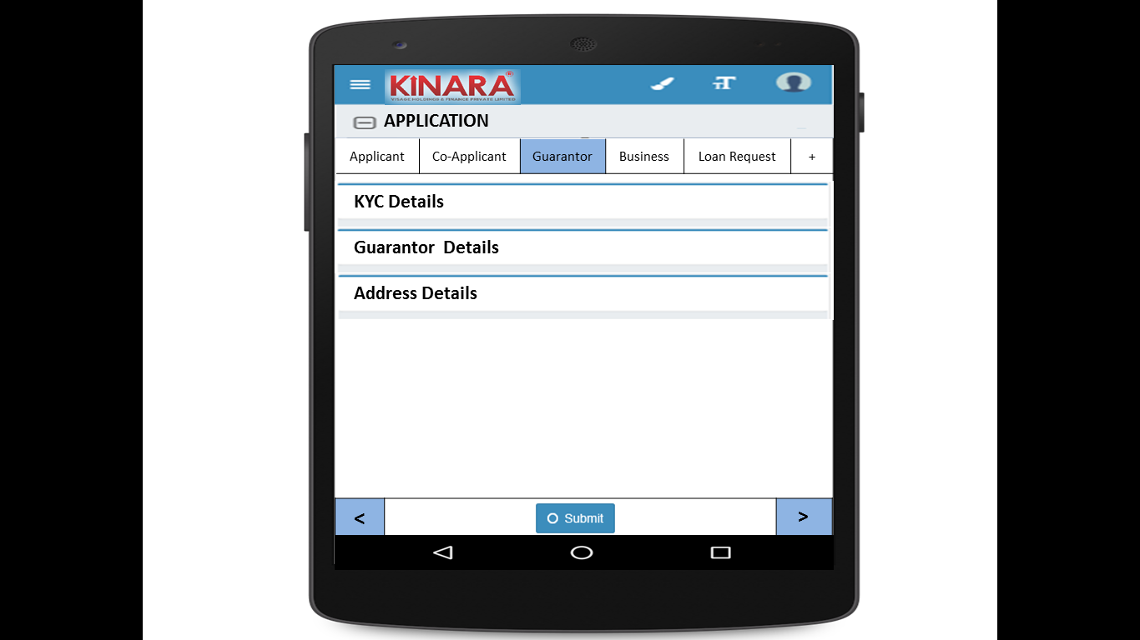

* + - 1. KYC Details

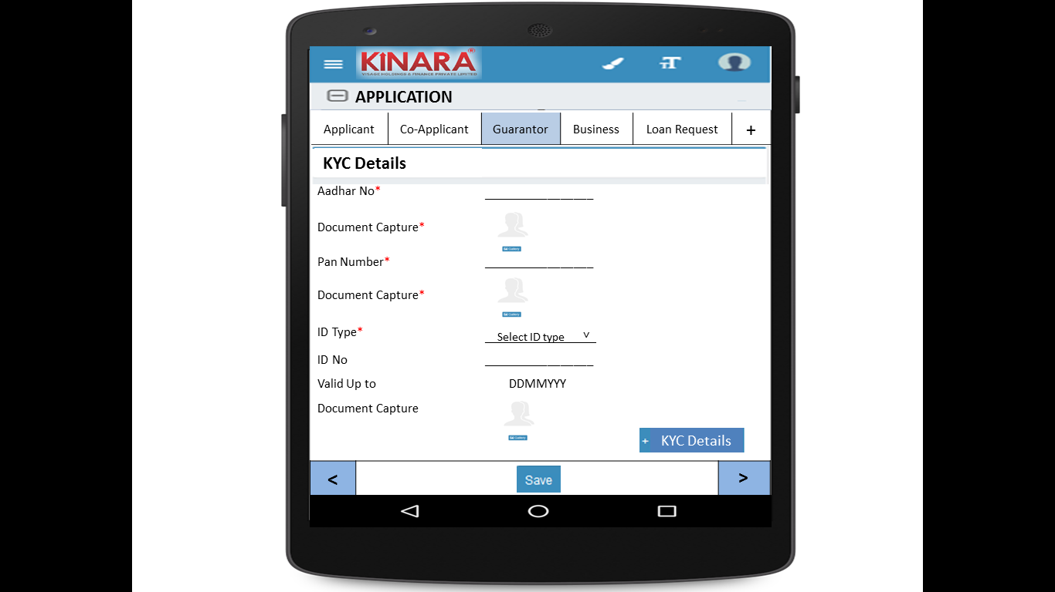

* + - 1. Guarantor Details

|  |  |  |
| --- | --- | --- |
| Page 1 | Page 2 | Page 3 |

* + - 1. Address Details

|  |  |
| --- | --- |
| Page 1 | Page 2 |
| Page 3 | Page 4 |

* + 1. **Business**

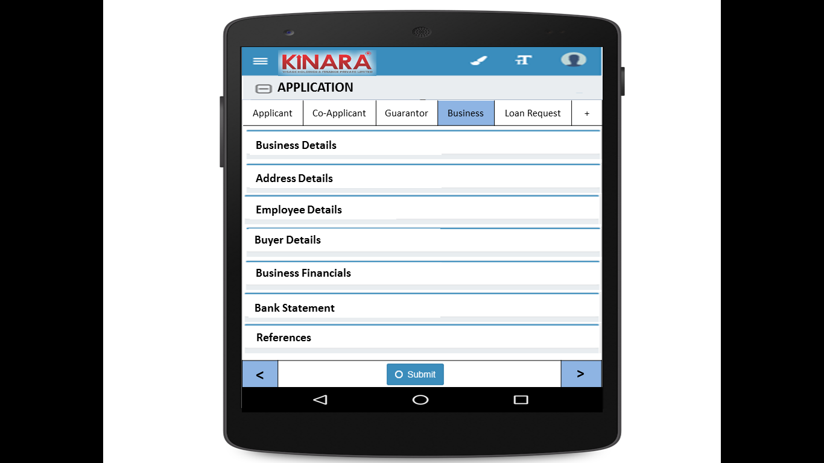

* + - 1. Business Details

|  |  |  |
| --- | --- | --- |
| Page 1 | Page 2 | Page 3 |

* + - 1. Address Details

|  |  |
| --- | --- |
| Page 1 | Page 2 |

* + - 1. Employee Details

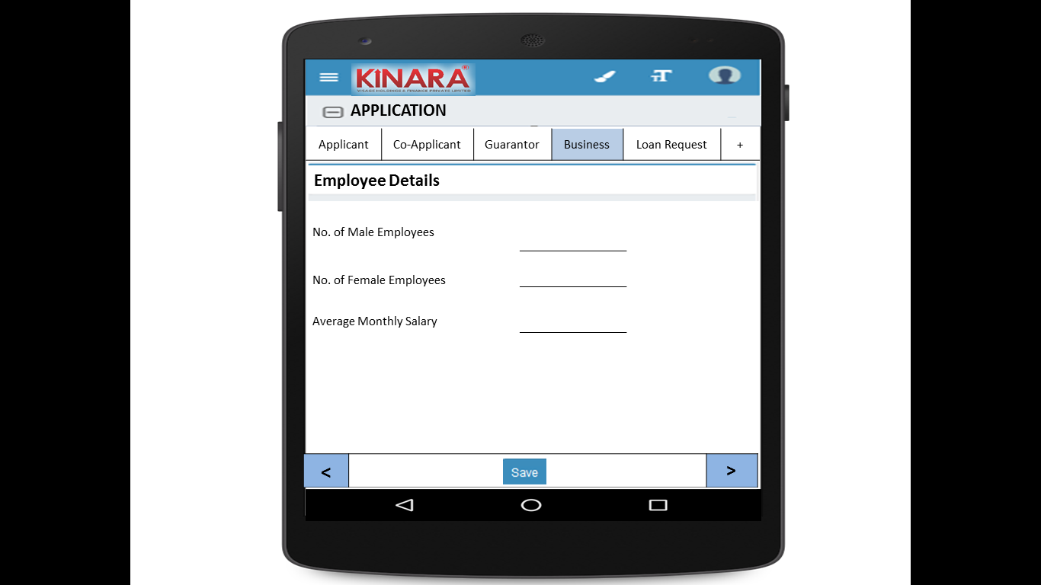

* + - 1. Buyer Details

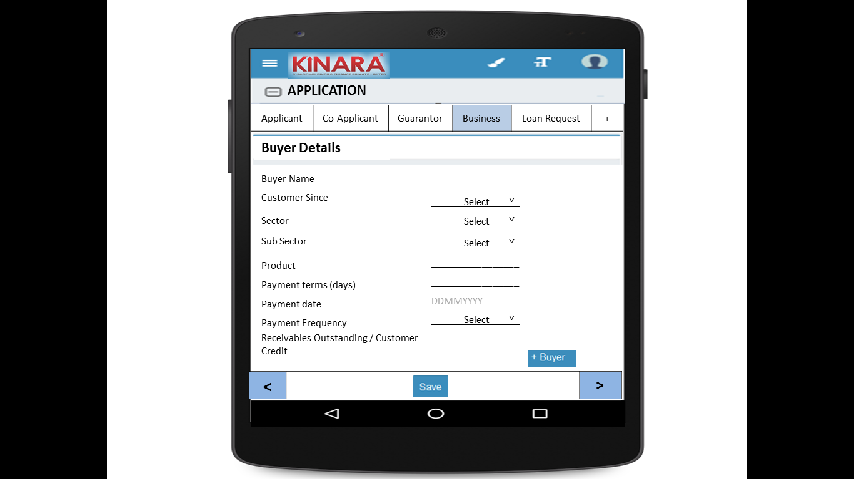

* + - 1. Business Financials

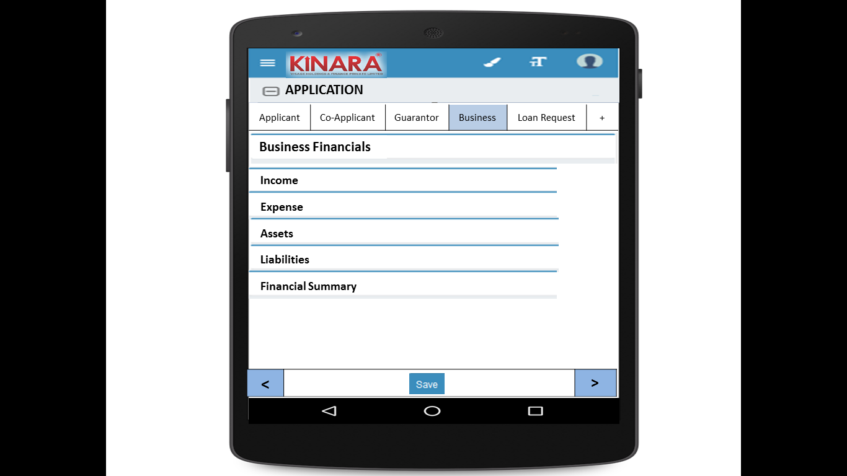

* + - * 1. Income

|  |  |
| --- | --- |
| Page 1 – Through Sales | Page 2 – Other Business Income |

* + - * 1. Expense

|  |  |
| --- | --- |
| Page 1- Raw material expense | Page 2 – Salary and wages |
| Page 3 – Fixed Obligations | Page 4 – Other Expenses |

* + - * 1. Assets

|  |  |
| --- | --- |
| Page 1 – Current Assets | Page 2 – Inventory |
| Page 3 – Machinery (1) | Page 4 – Machinery(2) |
| Page 5 – Other Assets | |

* + - * 1. Liabilities

|  |  |
| --- | --- |
| Page 1 – Fixed | Page 2 – Current |

* + - * 1. Financial Summary

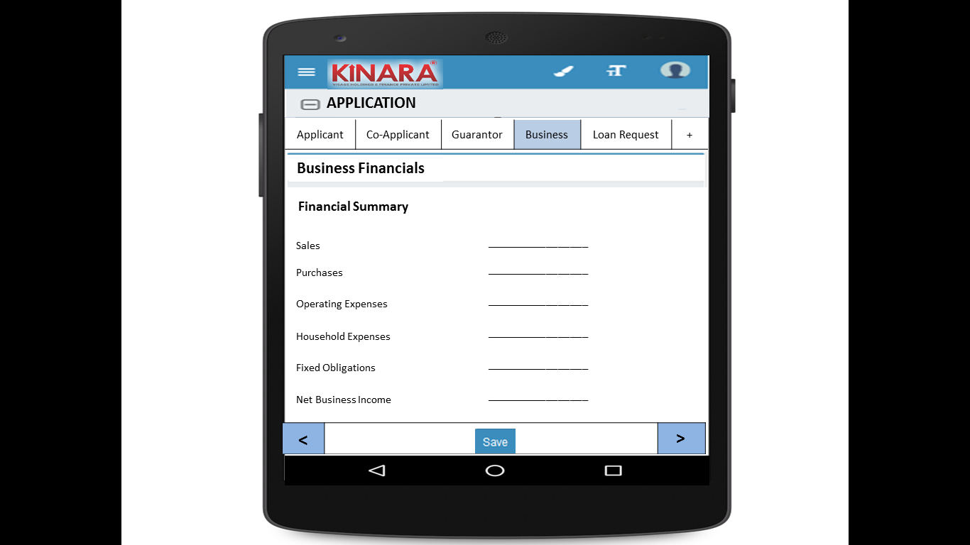

* + - 1. Bank Statement

|  |  |
| --- | --- |
| Page 1 | Page 2 |

* + - 1. References

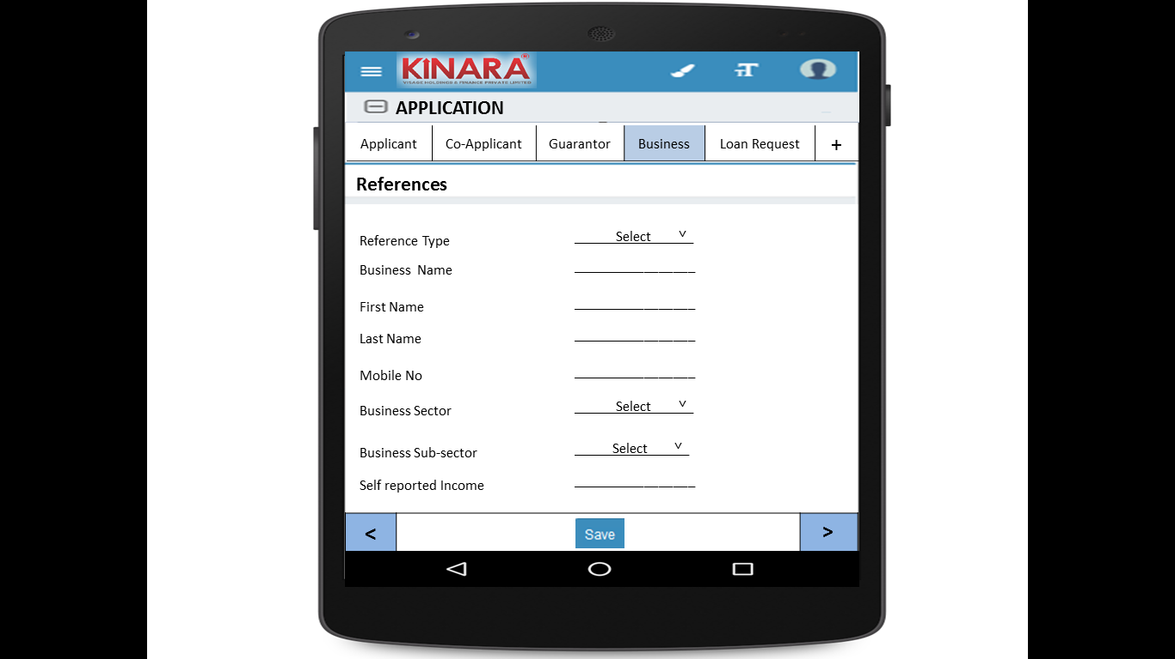

* + 1. **Loan Request**

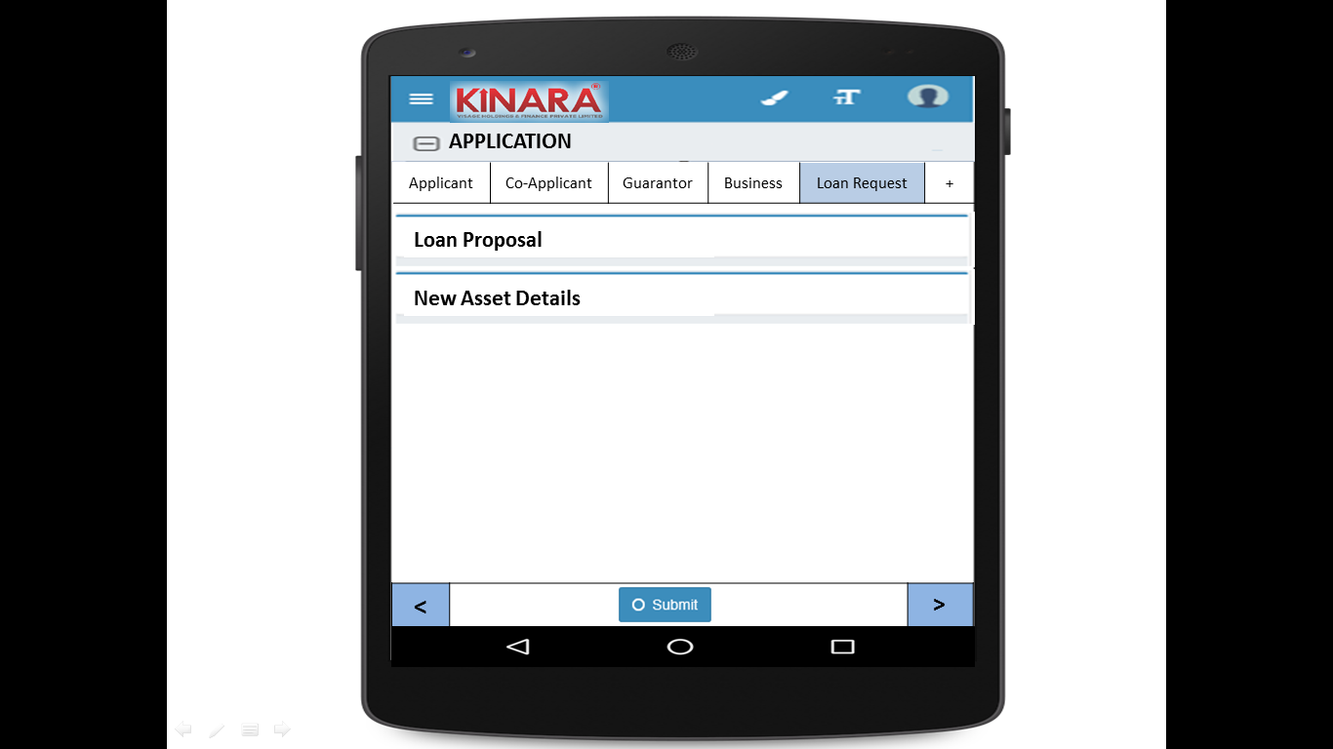

* + - 1. Loan Proposal

|  |  |
| --- | --- |
| Page 1 | Page 2 |

* + - 1. New Asset Details

|  |  |
| --- | --- |
| Page 1 | Page 2 |

## Functional requirements

* 1. Once the profile is selected from the application queue, the Loan Officer captures the application details data and submits the profile to undergo calculation of risk score 2 and an application review.
  2. Psychometric Test is also included in this stage
  3. Risk Score 2 will be calculated at the back-end on submission.
  4. All applications will be sent for application review (Auto-approval facility should also be included)

## Uploads

-NA-

## Downloads

-NA-

## Reports

-NA-

# PSYCHOMETRIC TEST

Refer Psychometric BRD for psychometric test

# RISK SCORE 2

## UI specification

-NA-

## Screenshot

-NA-

## Functional requirements

Risk Score 2 will be calculated by the system on submission of application details. The score will be calculated at the back-end on the basis of the following logic.

|  |  |  |  |  |  |  |  |  |  |  |  |  |  |  |
| --- | --- | --- | --- | --- | --- | --- | --- | --- | --- | --- | --- | --- | --- | --- |
| **S.No** | **Parameter** | **Stage** | **Entity** | **Main Tab** | **Field Name** | **Options** | **RS Option** | **Weightage in consolidated risk score** | **Weightage in screening score** | **Scoring** | | | | |
| **1** | **2** | **3** | **4** | **5** |
| 1 | Age | Application | Applicant | Applicant Details | Age |  | 1. < 25 2. 25 - 30 3. 30 - 40 4. 40 - 55 5. > 55 | 2 | 2/53 | 1 | 3 | 5 | 5 | 2 |
| 2 | Qualification | Application | Applicant | Applicant Details | Education Level |  | 1. Below SSLC 2. ITI/Diploma/ Professional Qualification 3. Graduate/ Equivalent to graduate 4. Post graduate & equivalent 5. More than post-graduation | 1 | 1/53 | 1 | 5 | 3 | 4 | 3 |
| 3 | Exp in Biz | Application | Applicant |  |  |  | 1. <2 years 2. 2-3 years 3. 3-4 years 4. 4-5 years 5. >5 years | 3 | 3/53 | 1 | 2 | 3 | 4 | 5 |
| 4 | # of Years residence in area /Locality | Application | Applicant | Address Details | How many years are you living in present Area? |  | 1. < 1 year 2. 1-3 years 3. 3-4 years 4.4-5 years 5. > 5years | 1 | 1/53 | 1 | 2 | 3 | 4 | 5 |
| 5 | Housing Status | Application | Applicant | Address Details | Ownership |  | 1. Owned 2. Own house without registration 3. Family Property 4. Leased 5. Rental | 2 | 2/53 | 5 | 4 | 3 | 2 | 1 |
| 6 | Married Status | Application | Applicant | Applicant Details | Marital Status |  | 1. Unmarried 2. Married 3. Separated 4. Divorced 5. Widow(er) | 1 | 1/53 | 4 | 5 | 0 | 1 | 3 |
| 7 | Involvement in Biz | Application | Applicant | Applicant Details | Business Involvement |  | 1. Full Time 2. Part Time 3. Not Involved | 3 | 3/53 | 5 | 3 | 0 |  |  |
| 8 | CB score | Screening | Applicant |  |  |  | 1. No data/ -1 to 5 2. 700+ 3. 600-700 4. 550-600 5.<550 | 6 | 6/53 | 3 | 5 | 4 | 2 | 0 |
| 9 | Psychometric Score | Application | Summary | Psychometric Test | Psychometric Score |  | 1. Failed in all parameters 2. Failed in more than 3 parameters 3. Failed in 2 parameters 4. Passed in 5 of 6 parameters 5. Passed in all parameters | 1 | 1/53 | 0 | 2 | 3 | 4 | 5 |
| 10 | Referred by | Application | Business | Business Details | Referred by |  | 1. Channel Partner 2. Existing Customer Referral 3. Direct (Cold Call) 4. Referral Partner | 2 | 2/53 | 5 | 3 | 1 | 2 |  |
| 11 | Business Vintage (verifiable) | Application | Business | Business Details | Business Operating since |  | 1. <6 months 2. 6 months to 1 year 3. 1-2 years 4. 2-3 years 5. >3 years | 3 | 3/53 | 1 | 2 | 3 | 4 | 5 |
| 12 | # of Years business in area /Locality | Application | Business | Business Details | How many years business in present Area? |  | 1. <6 months 2. 6 months to 1 year 3. 1-2 years 4. 2-3 years 5. >3 years | 5 | 5/53 | 0 | 1 | 2 | 3 | 5 |
| 13 | Business premises Status | Application | Business | Business Details | Ownership |  | 1. Owned 2. Own house without registration 3. Family Property 4. Leased 5. Rental | 2 | 2/53 | 5 | 4 | 3 | 2 | 1 |
| 14 | Business History | Application | Business | Business Details | Constitution | 1. Proprietorship  2. Partnership 3. Private LTD | 1. Clean - Single owner/ Structure | 2 | 2/53 | 5 | 4 | 3 | 1 | 2 |
| Business | Business Details | Constitution | 1. Proprietorship  2. Partnership 3. Private LTD | 2. Partnership with 2 partners |
| If partnership, how many total partners | 1. 2  2. 3 3. 4 4. >4 |
| Business | Business Details | Constitution | 1. Proprietorship  2. Partnership 3. Private LTD | 3. Partnership with more than 2 partners |
| If partnership, how many total partners | 1. 2  2. 3 3. 4 4. >4 |
| Applicant | Applicant Details | Have you ever been a proprietor or partner of any other company | 1. Yes 2. No | 4. Previously closed another business |
| If yes, did the business close? | 1. Yes 2. No |
| Business | Business Details | Has anyone else been a partner of your present business | 1. Yes 2. No | 5. Previously dissolved partnership |
| If yes, when was that partnership dissolved? | Date |
| 15 | Commercial High mark / CIBIL | Screening | Business | CB Check |  |  | 1. No Data 2. STD 3. Sub DBT, Loss | 5 | 5/53 | 3 | 5 | 0 |  |  |
| 16 | No of cheque returns including EMIs | Application | Business | Bank Statement Details | No. of cheques bounced |  | 1. 0-1 2. 2-3 3. 3-4 4. 4-6 5. >6 | 4 | 4/53 | 5 | 4 | 3 | 1 | 0 |
| 17 | Number of EMI bounces | Application | Business | Bank Statement Details | No of EMI cheques bounced* |  | 1. No Bounces 2. Technical Bounces paid in same month 3. 3 bounces paid in same month 4. >3 bounces paid after the month | 5 | 5/53 | 5 | 4 | 2 | 0 |  |
| 18 | No of Bounces in Kinara loan track |  |  |  |  | From Kinara records for existing customer ID for applicant/ Business | 1. No Bounces 2. Technical Bounces paid in same month 3. 2 bounces paid in same month 4. >2 bounces paid after the month | 5 | 5/53 | 5 | 4 | 2 | 0 |  |
| **CONSOLIDATED** | | | | | | | | **53** | **100%** |  |  |  |  |  |

## Upload

## Download

## Reports